Experiment 13.1.1
Name – Kanhaiya Tyagi Prn – 25070521157

Algorithm –
- Start
- Input
- Read max_value from the user.
- Initialize
- Create an empty list fib_sequence
- Set a = 0 and b = 1
- Loop Condition
- While a ≤ max_value, repeat steps 5–6:
- Store Value
- Append a to fib_sequence
- Update Values
- Set a = b
- Set b = a + b (using previous values)
- Exit Loop
- When a > max_value, stop the loop
- Output
- Return (or display) fib_sequence
- End

Excecution –
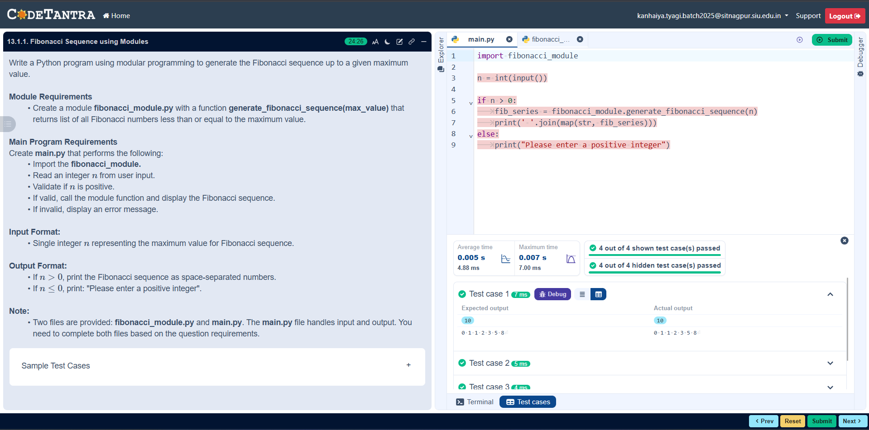
Flowchart –
